Experiment 2- Vector Forces
Objective: The experiment is aimed at examining the equilibrium forces by the use of parallelogram/ triangle rule.
Theory
According to Freyd (1988), objects at rest can be described in relation to the forces operating on them physically, forces that are balanced in astatic scene. On this experiment, we have a hypothesis that the statistic perception objects and the scenes might have an involvement of the underlying dynamic (P.35). In relation to Newton’s first law, an object is not in apposition to accelerate is there is not force acting on it and so the body object will be at rest. A vector refers to a quantity having both direction and magnitude, this includes displacement, force, acceleration and velocity and they at all-time follow the addition rules.
Weeks (1971) states that, both the repulsive and attractive forces have huge roles to play in the formation of the equilibrium structure of various liquids. The different effects of the attractive and repulsive forces can be separated easily in consideration of its structure and not the pair correlation functioning by itself. Within the large and intermediate wave vectors, forces of repulsion have great dominance in the quantitative behavior of various liquid structures. The forces of attraction have great manifestation on the small and the primary vector waves as part of the structural factors and this increases with the increase in the density which is negligible when there is reduced densities which are high above the 0.65 (p.5240).The establishment of the conclusions involves great consideration of the structural factors of the hypothetical systems which the intermolecular forces are entirely repulsive and similar to the forces of repulsion within the fluid.
The static theory assumption are among the conditions which are necessary to attain equilibrium determinate. This is known as the condition which were are in position to give our scientific accurate explanation or description of the real economic phenomena. After all these have been accepted generally and is accepted as being limitation when the deductive speculation have to continue and any other discovered element will be able to shape the.
Figure 1 is a force of board having weights suspended by tiny wires over pulleys. Both force one (F1) and force two (F2) are balanced by force three (F3). Both three forces act within a common central point as well as the total force which acts at the various points in Fr= F1+F2+F3. Having balanced forces or at the central point (equilibrium) the overall force acting is zero.Fr=F₁+F₂+F₃=0.
When this is rearranged, we get it to be F₁+F₂ =-F_{3.} In addition of two vectors, F1+F2=R=-F3, thus the weight of the resultant R and the Vector F3 are the same.
The negative sign (–F3) means that, R and F3 are in opposing directions.
According to Weltner (2009), in the field of engineering and physics, there are various quantities that must be specified by the both direction and magnitude. Examples of such quantities that incorporates velocity include the vectors also called the vector qualities (P.11). Vectors can be shown using lines drawn to scale in the right direction. The situation in Figure 1 can have a representation by vector diagram indicated in figure 2.The result of vectors in F1 and F2 can be found with the help of the parallelogram law. If line F1 and F2 are seen as being the two sides of the parallelogram as indicated, the diagonal is as a result of Vector R as indicated in the parallelogram figure. The weight of the parallelogram’s diagonals can be determined by the use of both mathematical and graphical methods.

Procedure
- Set up the apparatus as indicated I n the figures above. Place masses at the end of each wire till all is balanced at central point.
- Attach A4 paper behind the wires as you draw directions of the F1, F3 and F4.
- Take measurement and have the record as M1, M2 and M3.
- Do the calculations of the values of all the three forces. This is illustrated as; F₁=M₁.g or F₃=M₃.g etc.
- Using Graphical Methods; Apply the triangle or parallelogram law for the added force. Graphically add F1 and F2, then determine the vector’s length representing R which is the resultant force. Do the value comparison of R and F3.
- Mathematical formula, resolving the F 1, F2 and F3, to the vertical and horizontal components, always check if the system in at central point.
- Do a comparison of both the mathematical and graphical method used to determine the magnitude of Resultant force R.
- Draft a report considering the provided guidelines.
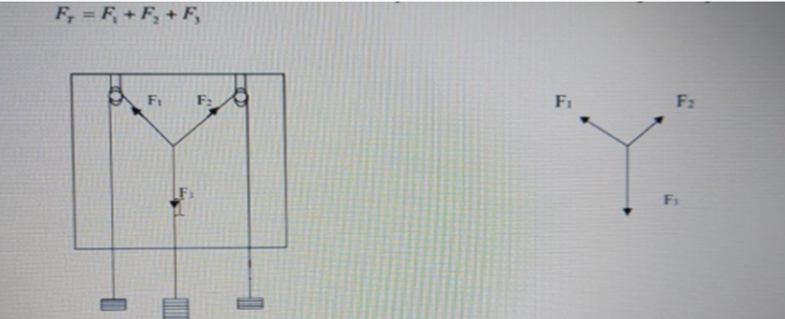
Figure 1 Figure 2
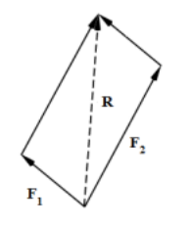 F1 + F2= R
Figure 3
Work cited
Freyd, J.J., Pantzer, T.M. and Cheng, J.L., 1988. Representing statics as forces in equilibrium. Journal of Experimental Psychology: General, 117(4), p.395.
Weltner, K., Schuster, P., Weber, W.J. and Grosjean, J., 2009. Vector Algebra I: Scalars and Vectors. In Mathematics for Physicists and Engineers (pp. 1-21). Springer, Berlin, Heidelberg.
Weeks, J.D., Chandler, D. and Andersen, H.C., 1971. Role of repulsive forces in determining the equilibrium structure of simple liquids. The Journal of chemical physics, 54(12), pp.5237-5247.

